**This document refers to the financials indicator on the value graph  
  
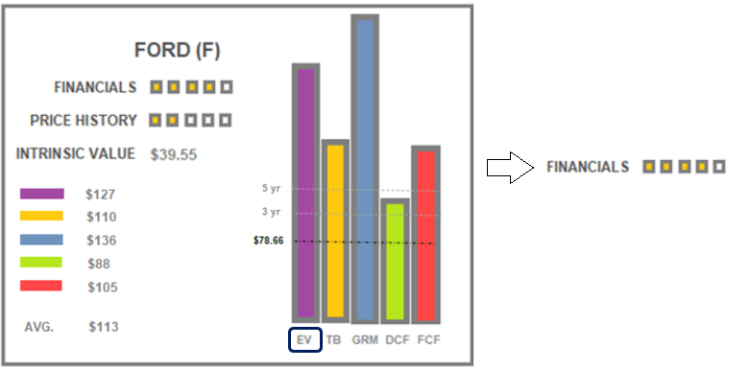**

1. There are 6 metrics and 5 boxes therefore use multiple of 30 , so every 5 points (see below) fills one square. For remainder points, if > 3 points fill square, if < 3 points, do not fill square.
2. We are calculating 6 metrics. Below gives the point distribution for each metric.
3. For the metrics **Revenue** and **Ebit** and **Cashflow** we’re looking at trends. Therefore, we must calculate a straight-line regression and note whether the line is positive (upward slope) flat (no slope) or negative (down slope).   
     
   * For regression, use 12 quarters of data for these starting with most recent quarter.
4. For the metrics **revenue, debt to equity,** and **current ratio,** Intrinio provides these (see below)
5. For **Altman Z score**, Intrinio provides all of the tags needed. The calculation is below.

**FINANCIALS**

* Revenue
* Ebit trend
* Debt to equity
* Current ratio
* Altman Z
* Free cashflow (to firm)

|  |  |
| --- | --- |
| **USE STRAIGHT LINE REGRESSION FOR REVENUE AND EBIT**  REVENUE If Recent year Revenue is down or even (95%) over three years assign weight  If revenue trend is moving upward over 5 years assign weight | 0  5 |
| EBIT If Recent year EBIT is down or even over three years assign weight  If EBIT trend is upward over 5 years assign weight | 0  5 |
| DEBT TO EQUITY If Recent year d/e is >2 assign weight  If Recent year d/e is < 2 assign weight (good) | 0  5 |
| CURRENT RATIO If Recent year Current is < 1.5 assign weight   If Recent year d/e is > = 1.5 assign weight (good) | 0  5 |
| ALTMAN Z If Recent Altman Z is < = 1.8 assign weight (bad)  (0) is more likely indicator  If Recent Altman Z is between 1.8+ to 3 assign weight   If Recent Altman Z is 3.0 or > assign weight | -10   2.5   5 |
| FREE CASHFLOW  If Free cashflow is negative and 5- year downward trend  If free cashflow is negative and 5 -year upward trend  If free cashflow is + and 5 - year downward trend  If free cashflow is positive and there is a 5 year flat or upward trend | -5  0  2.5  5 |

**CALCULATIONS**  
  
CALCULATE ALTMAN Z SCORE

* Zeta (ζ) is the Altman’s Z-score
* A is the Working Capital/Total Assets ratio
* B is the Retained Earnings/Total Assets ratio
* C is the Earnings Before Interest and Tax/Total Assets ratio
* D is the Market Value of Equity/Total Liabilities ratio
* E is the Total Sales/Total Assets ratio

PRICE HISTORY  
If = > 3 - year average 1  
If 5 % < 3 - year average 2  
If 10 % < 3-year Average 3  
if 15 % < 3 - year Average 4  
if 20+% <3 - year Average 5

**​**ζ = 1.2A + 1.4B + 3.3C + 0.6D + 1.0E

Where:

* Zeta (ζ) is the Altman’s Z-score
* A is the Net Working Capital/Total Assets
* B is the Retained Earnings/Total Assets
* C is the Earnings Before Interest and Tax/Total Assets
* D is the Market Value of Equity/Total Liabilities
* E is the Total Sales/Total Assets

**INTRINIO TAGS**   
  
**ALTMAN Z**   
  
(yes = Intrinio has the tag)   
  
A Net working capital = yes total assets = yes

B Retained Earnings = yes total assets = yes

C EBIT = yes total assets = yes

D MVOE = Market capitalization = yes total liabilities = yes

E Total sales = total revenue = yes total assets = yes   
  
  
**REVENUE** = yes

**EBIT** = yes

**DEBT TO EQUITY** = yes **CURRENT RATIO** = yes  
  
**FREE CASHFLOW** = yes